Refining Research on Joy

Lynn G. Underwood
Case Western Reserve University

Author Note
Correspondence concerning this article should be addressed to Lynn G. Underwood, Ph.D., Inamori International Center for Ethics, Case Western Reserve University, Cleveland, OH 44106. E-mail: lynn@lynn.underwood.com

Abstract

This article suggests ways to enhance joy research. Wording choices for eliciting reports of joy are crucial. Reporting strategies such as ecological momentary assessment can make a big difference. The arts can be a novel way of eliciting reports and experiences of joy in the context of research. Certain individual differences and subtypes of joy should be included. Joy research may be more profitably done in the context of other wider or overlapping constructs rather than doing joy research in isolation, so that research results can be most useful for people. How joy occurs in the midst of tough times is an especially important area to explore. The Daily Spiritual Experience Scale contains items that tap joy for many people. It may prove fruitful as a tool, and provides an example of the utility of bottom-up research.
Keywords: joy, spirituality, research methods, quality of life

Refining Research on Joy
To find out about joy using the tools of scientific research we must identify what connects joy of all kinds for many people, something that comes under the wide umbrella of joy, in order to find some common features. Nevertheless, we also need to continue to parse the many conceptual distinctions found under this umbrella. The kinds of joy that happen together with sorrow differ from unmixed joy. Variations in intensity may describe joy of very different kinds. Quiet joy that looks more like deep contentment might be very different from ecstatic joy. Joy that occurs with others, either with other people or a divine other, may seem quite distinct. Acknowledging this complexity, we can develop sound methods and measures to study joy empirically. And each of us is temperamentally different. Some of us experience the most profound joy in solitude, some of us when with others. Some of us find frequent calm joy, others have frequent highs in experiences of joy. For some joy is inextricably linked to a sense of the transcendent, for others there is no awareness of transcendence in their experiences. The words used to tap into this need to give space for all of these kinds of joy.
When we think of a word to describe the umbrella concept of joy, I think of how the word has been translated in the Daily Spiritual Experience Scale (DSES) into 40 languages using back translation methodology (Underwood 2011). One item uses the word joy, and here is a sample of the words used: radost, 喜悦 , আনন্দ , glæde, vreugde, kagalakan, joie, Freude, Χαρά , öröm , áthas, gioia, 즐거움 , prieks , džiaugsmas ,kegembiraan , സന്തോഷം ,alegria , radość , bucurie , радость, हर्ष , радост, potešenie ,veselje ,alegría, ความปิติยินดี , sevinç ,радість, שמחה , فرح, خوشی .
Apart from the single word, the language surrounding the specific word used for joy that is used to elicit reports of these experiences is also important. When doing ecological momentary assessment different words can point to trait or state joy, for example: “Are you a joyful person?”, or “Are you feeling joyful right now?”. And other ways of eliciting reports may depend on some kind of memory of events in asking about frequency of experiences over the past while, ranging from many times a day, to some days, to never. The choice was made when developing the DSES to ask this question about frequency rather than intensity. When we measure joy, we need to also attend to whether frequency, or intensity, or degree of agreement with a statement, might be most important for the research question of interest.
Related to this is the wider question on how to shape a research agenda. Is it best to cordon off ‘joy studies’ from studies of compassionate love, awe, generosity, self-acceptance, spiritual connection, or feeling profoundly blessed? Is joy really that separate? How is it related to many other qualities of being and characteristics? Separating out joy from other constructs may not be the best way to go about developing a research agenda that will help us to improve life for people.
A word in modern informal Hebrew, Firgun ( פירגון‎ ) describes “generosity of spirit and the unselfish joy that something good has happened or might happen to someone else”. Another possible definition describes firgun as a genuine, unselfish feeling of delight or pride in someone else's accomplishment. Many of us would recognize this attitude. It seems to overlap with constructs beyond joy, so where would it fit in studies? There has been a tendency in studies, partially because of funding mechanisms of various kinds, to separate out our research into categories of virtues or feelings or characteristics. This may actually get in the way of producing results that are most useful to people in their lives.
But if a researcher wants to cordon off the investigation of joy, it can be useful as long as it is conceptually clear and realistically linked to other constructs. This may allow certain good questions to be asked. Can joy motivate people to give of self for the good of the other or sustain other virtues? Can joy in the midst of life’s challenges help us to be courageous, and see beyond our momentary troubles? Can joy draw our focus to the big picture, and remind us of transcendent features of life, often described in spiritual or religious terms? Research specifically on joy has the capacity to shift the popular focus from what we can do to increase our happiness, which has dominated much of the popular press recently as well as many of the research studies, to a greater focus on joy. Joy can be a valuable outcome, with a richness and a power that is unique and sustaining, even if not always as bright and shiny in the moment as happiness
Joy in tough times
An area of special interest for future research may be how we can experience joy even in tough times. Frequently we see that people can be joyful even in the midst of trouble. People can thrive during trauma and disease and are often joyful even in the midst of loss and grief. Are there ways we can foster this for people who have experienced trauma or are distressed?
“The happiness mentality causes people to repress or deny many of their own negative feelings. It prohibits the rich experience of living through painful situations, of fully feeling and being in the sadness, grief, and fear that are natural parts of human existence. It fosters a pastel quality of life, with limited ranges of emotion. Some shallow conditions of ‘happiness’ may be achieved in this way, but joy is altogether out of the question. Most of us know that prohibiting agony in the experience of life must also prohibit joy. To try to accomplish one without the other is to dilute both the experience and the meaning of life….At best, this watered-down existence takes on a ‘Pollyanna’ atmosphere, denying the negativity of life. At its worst, it sinks into apathy, denying life itself.” (May, 1987)
It has been said that suffering carves valleys that then can be filled with joy. The sensitivity that is so often cultivated by sorrows has the capacity to enhance our experience of joy, and the contrast can make the joy taste that much sweeter.

The arts
If we want to study joy in its various forms and complexity, a valuable tool as a ‘prompt’ for experimental and observational work is art. The arts – music, dance, film, video, and visual art – have the capacity to stir joy in us. And in doing so can help us to both define the construct more clearly and study it better. The particular pieces of art that elicit joy for each person varies by temperament, situation, cohort, and culture. Because of this, selecting examples offered by the subjects themselves, may be more effective as prompts than imaginary scenarios or examples designed or selected by the researchers.
Relevance of the Daily Spiritual Experiences Scale to Research on Joy
In doing research on compassionate love, we have seen that research is enriched when we do structured interviews with both ordinary and extraordinary people before settling on final definitions and research hypotheses (Underwood, 2008). This has also been the case in a research project on subjective well-being of those with HIV-AIDS with the World Health Organization, especially when it was trying to fold in a religious/spiritual dimension (WHO HIV-AIDS Group, 2004). As we study joy, we need to explore how joy unfolds in the details of people’s days, before constructing the shape of research and scholarship, choosing the kinds of questions wisely that enable people to describe their experiences of joy, in order to get at the depths and complexity involved.
As an example of this, the development, content and resulting research on the Daily Spiritual Experience Scale (DSES) has relevance for the study of joy (Underwood & Teresi 2002). In the process of doing structured interviews on ordinary spiritual experiences in daily life with many people from various cultures, religious approaches, and socioeconomic status, this author heard in detail about some of the ordinary joys present in people’s days. The interviews also included a substantial international sample drawn from a World Health Organization project. One reason for discussing the DSES in depth here is because a few of the items have special applicability to ‘measuring’ the experiences of joy. They do not comprehensively grasp all kinds of experiences of joy, but can give a taste of how joy in a spiritual context might be measured and ‘work’ in a research setting. The sixteen DSES questions were designed to measure ordinary experiences that many would refer to as spiritual or religious, and the scale works with most faith traditions and spiritual approaches and also for those not comfortable with religion. It has been used in over 400 published studies worldwide, showing correlation with more resiliency, less burnout, less PTSD, less addictions, and greater post traumatic growth. (Barton and Miller, 2015; Currier et al 2013; Howell et al 2014; Lee et al 2014; Wachholtz and Rogoff 2013; www.dsescale.org ). Although the number scores have helped to demonstrate correlations and can show change over time that is significant, using the DSES in the form of open-ended questions also has the capacity to call people’s attention to how these might be expressed in their days, especially after being prompted by how and when others have experienced these. This method, and some of these answers can inform our future study of joy.
One of the DSES questions asks how and when people have felt joy that lifted them out of their daily concerns during worship, or at other times when experiencing a connection with God or the divine. In the structured interviews used to develop the DSES, some of the answers were:
- “When listening to some kinds of music, I feel ecstatic, a divine connection.”
- “Being silent in a very old building with high ceilings can be uplifting to me.”
- “My concerns fade into the background sometimes when I am singing religious music with others.”
- “When standing looking out over the hills.”
- “When I see the success of others and feel excited by their success.”
- “When I am working outside, and look up and see light in the sky through the clouds, I realize more what matters, and my troubles fade.”
- “During an Irish funeral wake, and the celebration surrounding that time.”
More on the contents of the interview results from the other questions can be found in Underwood (2006) and Underwood (2013). These personal descriptions provide an example of how certain aspects of joy have been addressed cross culturally, in countries as diverse as India, China, Indonesia, Nigeria, France, Slovakia, Saudi Arabia and Lebanon. As we do research on joy in an international context, it is going to be very important to do this with cultural sensitivity.
In addition to the item mentioned above, DSES items that may also be relevant to the concept of joy include:
- How often do you feel deep inner peace or harmony?
- How often do you feel spiritually touched by the beauty of creation?
And there are other items in the DSES that can reflect moments of joy, such as the ones asking about how often they feel compassionate love from other people or a divine source (e.g. “A kind smile from a stranger in a public place” or “When I think back on happy events, I have a sense of being cared for”), the one on having a sense of connection to all of life, or reports of feeling thankful for blessings. When we examine the qualitative answers for when people have these experiences we find moments of joy. We may dispute whether these additional items get at the construct of joy for a wide swath of people, and further research will give greater clarity to this. People who need a feeling of stimulation or excitement for a sense of joy may not find joy in deep inner peace, for example. But there may be subsets of people for whom this is one of the main ways of experiencing joy. For some, they may find listening to uplifting music provides them a way to be “spiritually touched by the beauty of creation,” and this may elicit feelings of joy. For others, seeing a beautiful sunset gives a feeling of awe, but they may not describe this as joyful. These items can, however, give us an idea of how joyful experiences might be effectively measured in studies.
Since the DSES has been administered in the General Social Survey, we can see how the responses were distributed in a random US sample and this allows researchers to explore correlations of this aspect of joy with the many other variables in this open access database. The following table shows the population distribution of a few of the items that may have relevance to experiences of joy. One can see that although many people experience this frequently, there are a substantial number of people for whom these experiences are rare.
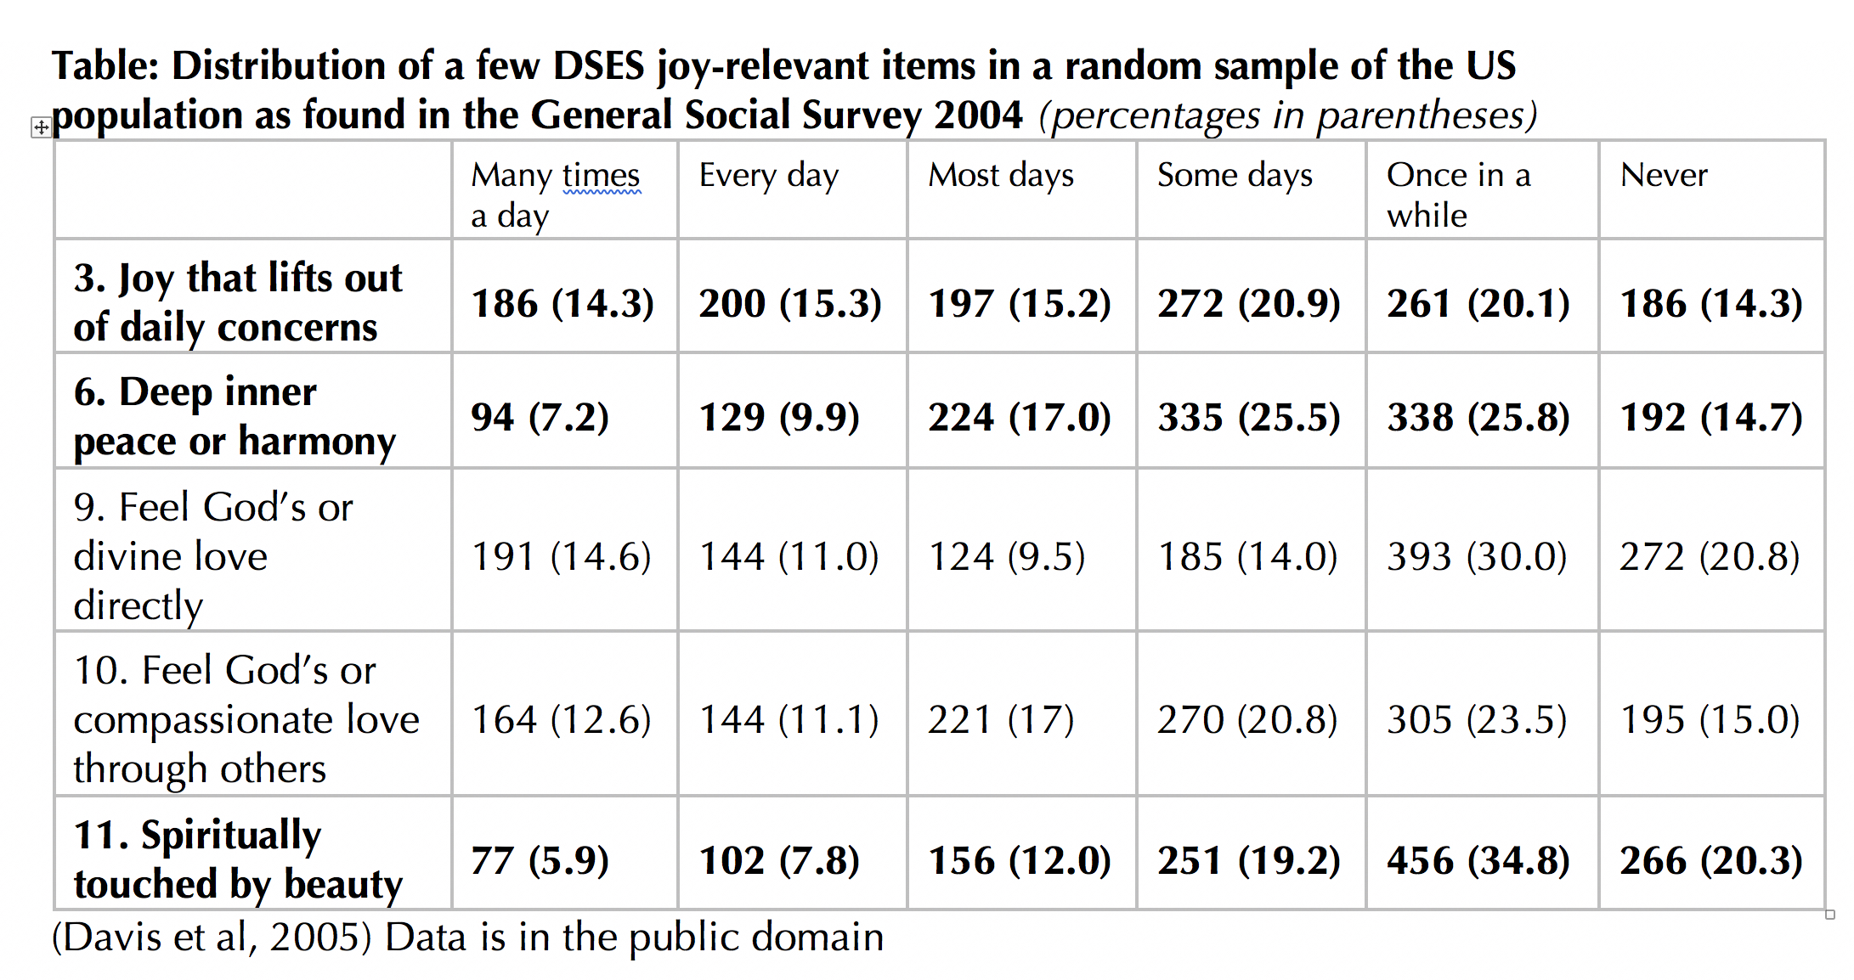
It is important to note that these positive experiences can be influenced by mood but are distinct in their predictions and time course from mood (Tong, 2017). The DSES items generally load on one factor in most studies. Even though each item measures something particular, and was designed to do so, they hang together overall. It may be as we develop measures of joy, a similar commonality yet differentiation may become evident as we address this complex and salient topic.
In Conclusion
We each have conceptions of what joy is in our own life, and what things cause us to be joyful, and we may have some sense of that for friends, family and colleagues. But we so often underestimate individual and subgroup differences and how they shape the definition of this construct. Some of us are pessimists by nature or nurture, but can still find delight in small things, or find pleasure in the successes of others that ‘lift us out of our daily concerns.’ It will be challenging to define joy in a way that differentiates it from happiness or positive mood. Just as defining spirituality from the top down seems to produce endlessly different definitions, trying to define joy from the top down may encounter similar issues, and it may be best to start by mining experiences and the contexts of those through research. As the work progresses, we can flesh out correlations in order to find out what predicts joy, and what joy predicts in different individuals’ lives.
References
Barton, Y., & Miller, L. (2015). Spirituality and Positive Psychology Go Hand in Hand: An Investigation of Multiple Empirically Derived Profiles and Related Protective Benefits. Journal of Religion and Health. 54(3), 829–843.
Currier, J. M., Mallot, J., Martinez, T. E., Sandy, C., and Neimeyer, R. (2013) Bereavement, religion, and posttraumatic growth: A matched control group investigation. Psycholog. Relig. Spiritual. 5, 69–77.
Davis, J. A., Smith T. W., and Marsden, P.V. (2005) General Social Surveys (1972–2004) Chicago, IL: National Opinion Research Center, 2005. Storrs, CT: Roper Center for Public Opinion Research, University of Connecticut/Ann Arbor, MI.
Howell, K. H., & Miller-Graff, L. E. (2014). Protective factors associated with resilient functioning in young adulthood after childhood exposure to violence. Child Abuse and Neglect, 38(12), 1985–1994.
Lee, Matthew T., Paige S. Veta, Byron R. Johnson, and Maria E. Pagano. 2014. Daily Spiritual Experiences and Adolescent Treatment Response. Alcoholism Treatment Quarterly 32 (2-3), 271–298.
May, Gerald. (1987). Will and Spirit. Harper and Row. pp 14-16.
Tong, E. M. W. (2017). Spirituality and the temporal dynamics of transcendental positive emotions. Psychology of Religion and Spirituality, 9(1), 70–81.
Underwood, L. G., & Teresi, J. A. (2002). The daily spiritual experience scale: development, theoretical description, reliability, exploratory factor analysis, and preliminary construct validity using health-related data. Annals of Behavioral Medicine : A Publication of the Society of Behavioral Medicine, 24(1), 22–33.
Underwood, L. G. (2006). Ordinary spiritual experience: Qualitative research, interpretive guidelines, and population distribution for the daily spiritual experience scale. Archive for the Psychology of Religion, 28, 181–218.
Underwood, L. G. (2008). Compassionate love: A framework for research. In S. Sprecher, B. Fehr, & L. Underwood (Eds.), The science of compassionate love: Theory, research, and applications. Wiley Blackwell. (pp. 3–25).
Underwood, L. G. (2011). The Daily Spiritual Experience Scale: Overview and Results. Religions, 2(1), 29–50.
Underwood, L. G. (2013). Spiritual Connection in Daily Life. Templeton Press, West Conshohocken, PA.
Wachholtz, A., & Rogoff, M. (2013). The relationship between spirituality and burnout among medical students. Journal of Contemporary Medical Education, 1(2), 83–91.
WHO HIV-AIDS group (2004). WHOQOL-HIV for quality of life assessment among people living with HIV and AIDS: results from the field test. AIDS Care, 16(7), 882–889.

